SYNCHRONIZATION ?

WHY??

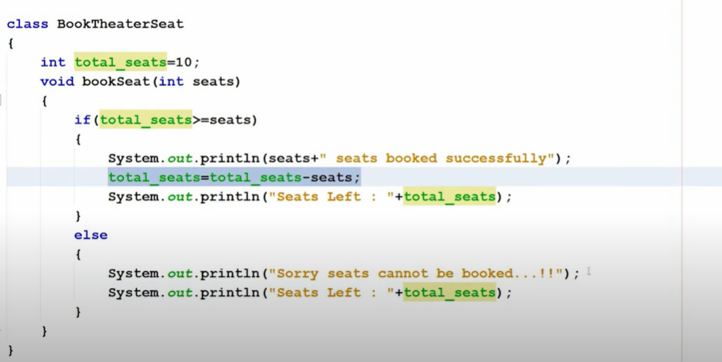

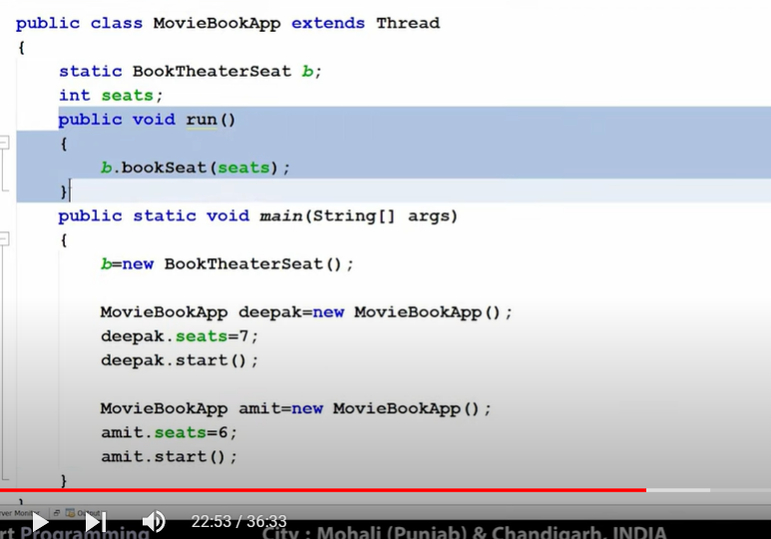

WE HAVE 2 CUSTOMER DEEPAL AND AMIT AND BOTH BOOK 6,7 SEATS IN AN APP.BUT WE HAVE ONLY 10 SEATS IN TOTAL. THREADING ALLOW TP BOOK BOTH USER SIMULATANEOUSLY AND WILL GIVE UNEXPECTED RESULT OTHER SIMILAR. E.G LIKE BANK TRANSACTIONS .

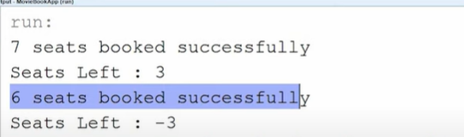

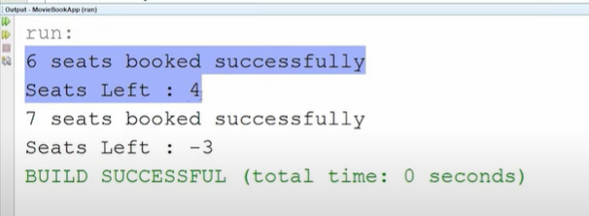

DIFFERENT OUPUT AT DIFFEREN T IMES WITH SEAT = -3 , SHOWING DATA INCONSITENCY . FIRST DEEPAK WILL BOOK THEN AMIT SHOULD BOOK!

THAT’S WHY WE USED SYNCHRONIZATION!

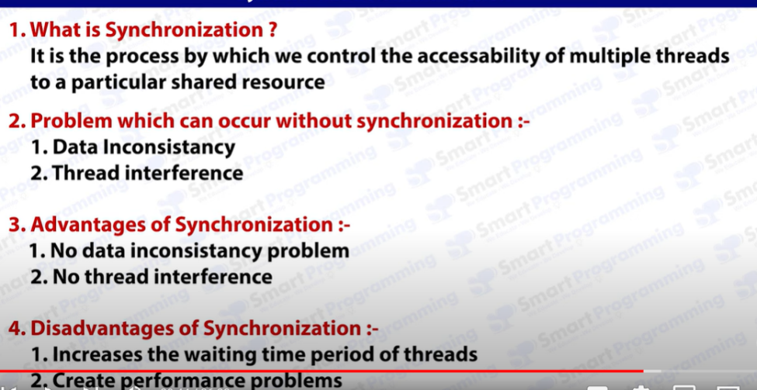

BUT HE DISADVANTAGES ARE COSTLY . TO MINIMIZE IT , WE HAVE A PACAGE JAVA.UTIL.CONCURRENT .

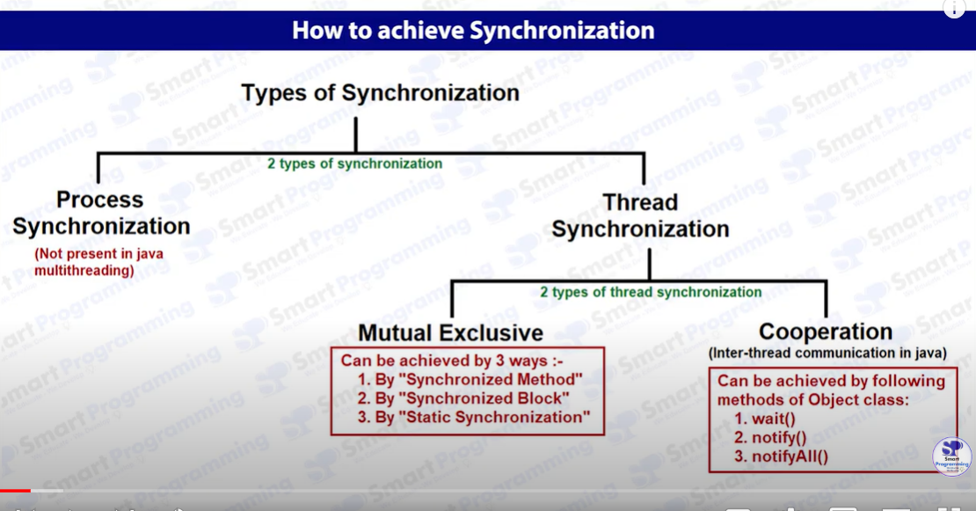

1. Synchronized method – Every object has a lock and every object has 2 areas . Synchronized ( all methods are synchronized ) and unsynchronized. When multiple thread try to access a single synchronized method , it can be hold by at most one thread at a time and other threads need to wait till the synchronized area lock is made free.
2. Using a single keyword synchronized solve the above problem.

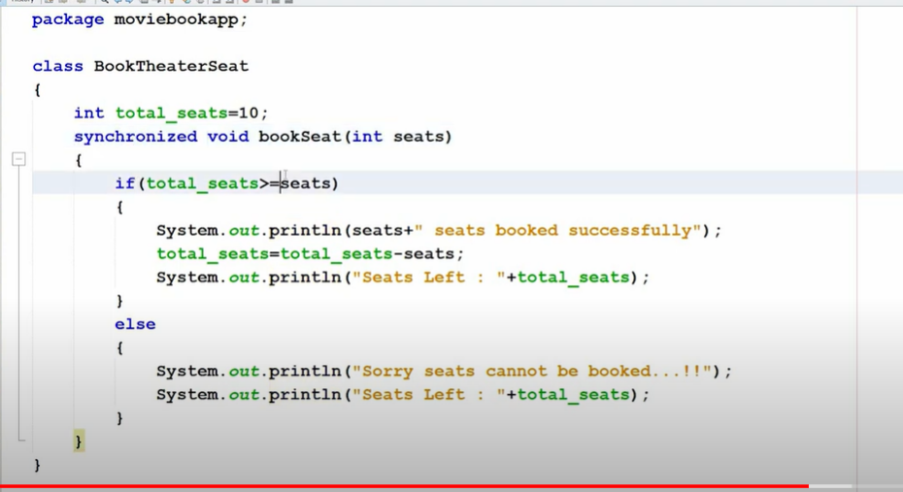

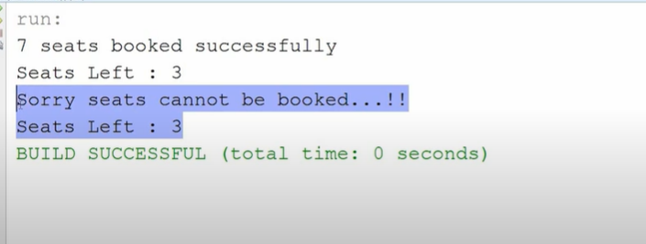

2>>Synchronized Block : If you have 1000 line inside a code and you want just 10 lines to synchronize or use lock so that a single thread can access that part at a time . You will increase waiting time since you just not only put that line a lock u ut all the 1000 lines under synchronization reducing efficiency.

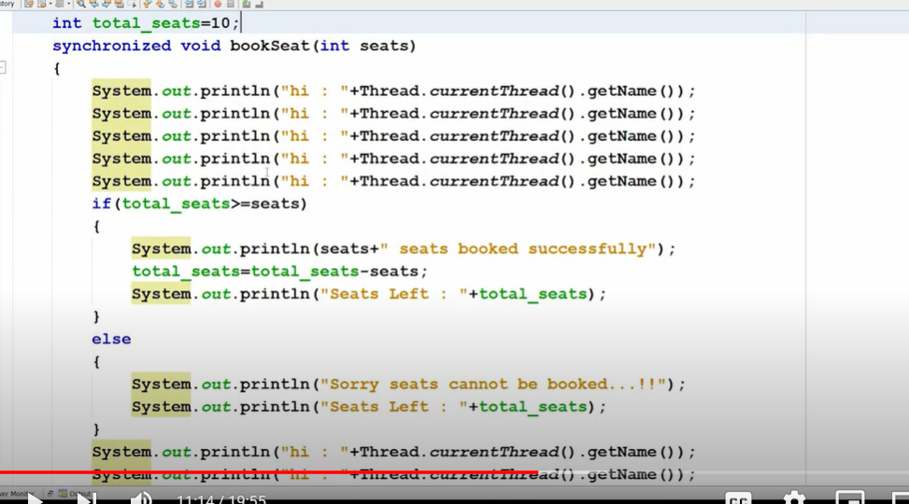

Like here all sop lines are waste still we put them under lock . we only need to put that if , else part under synzhronization.

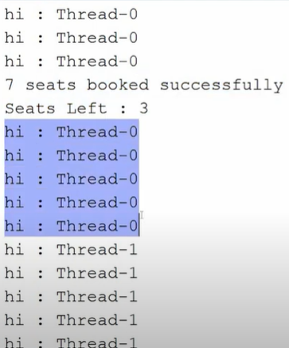’

Here whole thread-0 getting executed first then only thread-1 , even sop print is not necessary to occur.

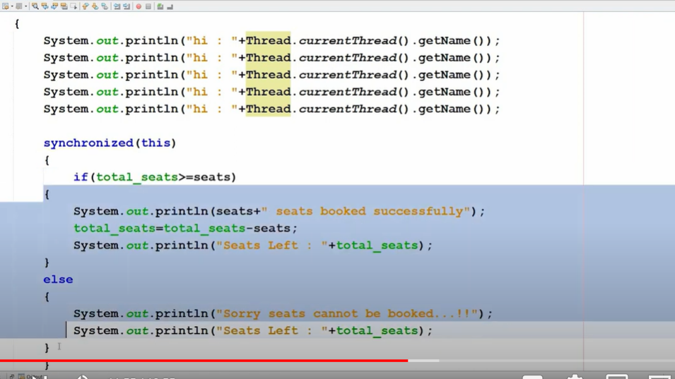

SYNCHRONIZED BLOCK : synchronized( this ) put the block of code lock under the current reference

.In place of this , user can pass object reference too.

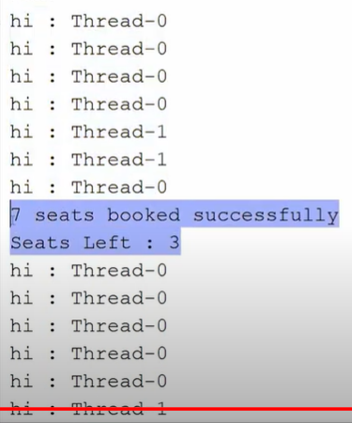’

Only seatbook part is under synchronization rest sop lines are executing simultaneously.

3>Static synchronization : We were having a single object B and using B we were handling different objects like Deepak,amit.So total seat was consistent for both Deepak , amit .But what if we create multiple object of B1,B2 and each object used by multiple users .

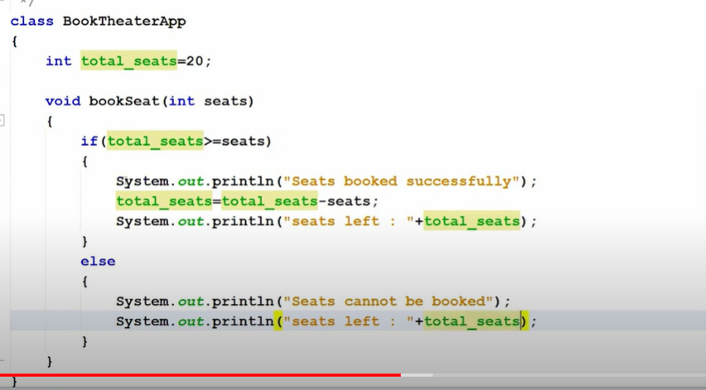

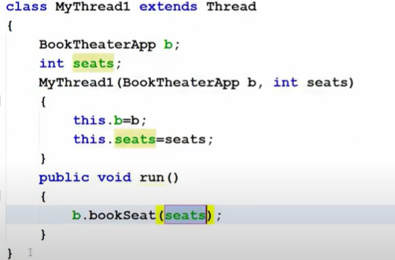

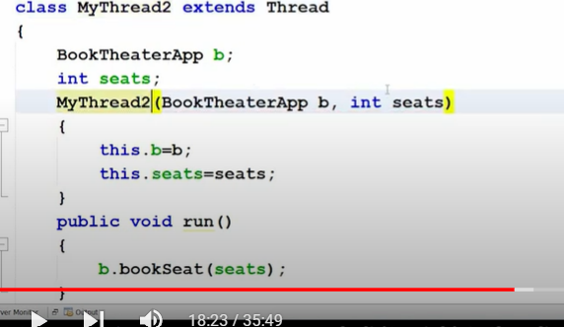

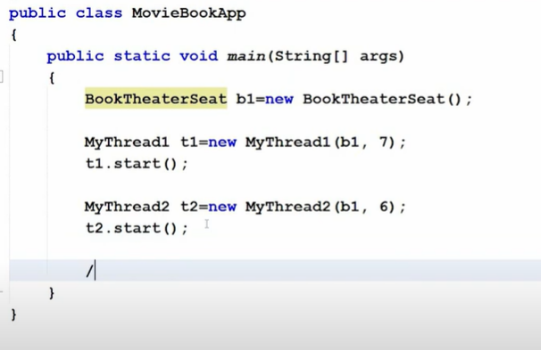

NO ERROE SINCE WE USED A SINGLE REFERNCE OF BOOKTHEATERSEAT . SO T1,T2 USER WILL BE SYNCHRONIZED CORRECTLY.

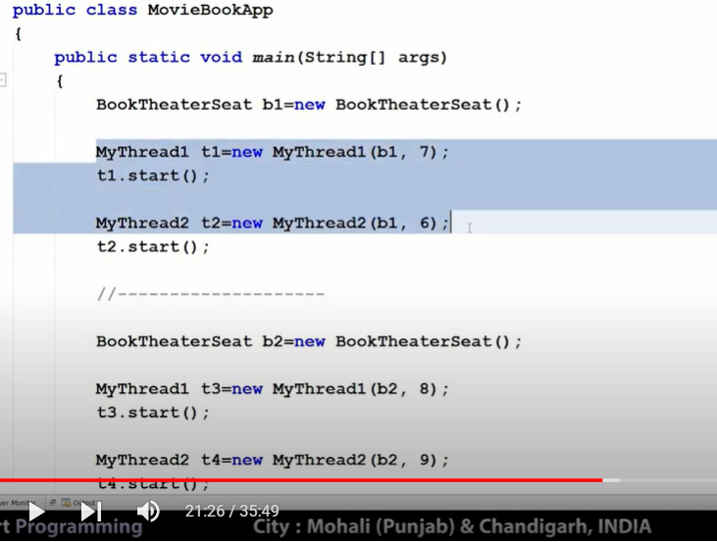

HERE WE HAVE PASSED TWO DIFFERENT REFERNCE TO BOOKTHEATERSEAT AND HENCE INDIVIDUAL REFENCE WILL HAVE TOTAL SEAT = 10 AND WILL GIVE UNEXPECTED BEHAVIOUR .

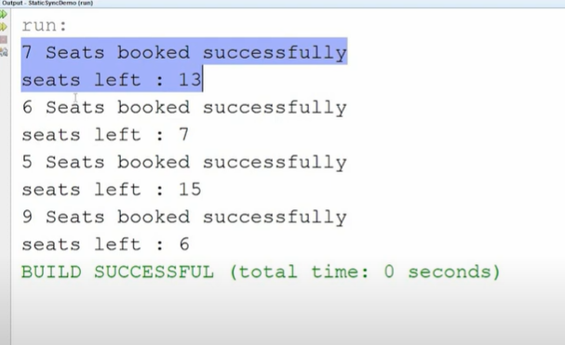

TO HANDLE THIS WE USE STATIC SYNCHRONIZATION WHICH PROVIDES LOCK NOT TO METHODS DIRECTLY TO CLASS

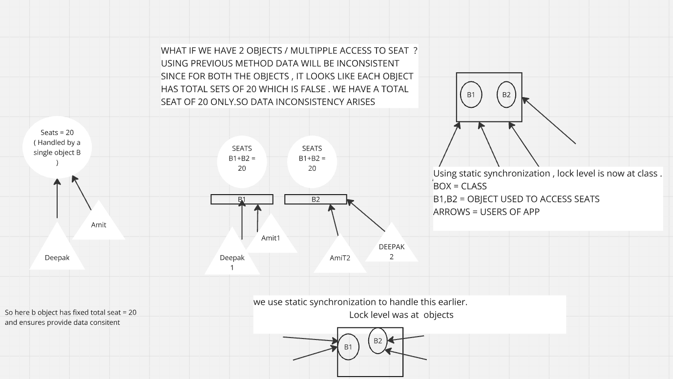

E.G

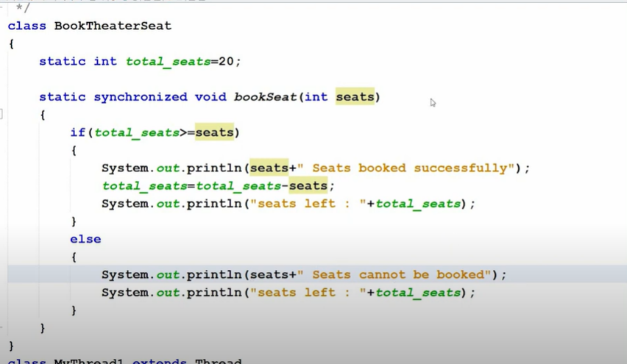

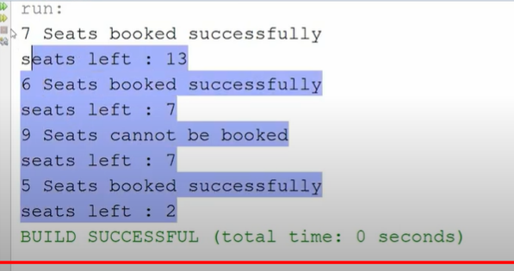

CORRECT OUPUT!!